**Assignment IV (MA226)**

**Name: Sourav Bikash**

**Roll No.:11012338**

**Submission Date: 01/02/2013 Time:23:59 hrs.**

**Aim of the Problem:**

The problem involves general sampling methods. Earlier we have introduced random number generation. Hence forth we assume the availability of random numbers through linear congruence generators. We also assume the availability of a sequence of random numbers. A simulation algorithm transforms these samples of uniform distribution to samples of other distribution. We will generate two distributions:

1. Exponential Distribution
2. Gamma Distribution

**Mathematical Analysis/Theory:**

The problem uses the following linear congruence generator:





It generates a sequence of xi and a dependent sequence ui.

Using the uniform sample we can generate samples of other distribution using various algorithms. In this assignment we make use of two most widely accepted general techniques:

1. The inverse-transform method.
2. The acceptance-rejection method.

**The inverse-transform method:**

This sets X=F-1(U), U~Unif[0,1]

Where F-1 is the inverse of F and Unif[0,1] denotes the uniform distribution on [0,1].

**The acceptance-rejection method:**

The acceptance rejection method, introduction by Von Neumann, is among the most widely accepted method for generating random samples. Suppose we want to generate samples from a function f(x) defined on the set S. And g(x) is the function from which we know how to generate samples. For the density function

f(x)< cg(x) for all xεS

for some constant c. here we generate a sample X from g(x) and accept the sample with probability f(x)/cg(x).

**Part I:**

This question wants to simulate a sample of size 5000 of exponential type with mean=5.

We use the following conversion:

z=-5*(log(u))

A sequence of xi was generated using the linear congruence generator. Using this a sequence of Ui was obtained and corresponding z was collected. The frequencies of the obtained Ui was plotted using a barplot.

**C++ implementation:**

#include<cstdio>

#include<iostream>

#include<cmath>

using namespace std;

int main()

{

int xo=5;

int initial=((1597*xo)+1)%244944;

double u=(double)initial/244944;

int x;long count=0;

double z;

double sum=0;double ave;

double max=0,min;

x=((1597*initial)+1)%244944;

while(count!=5000)

{

u=(double)x/244944;

x=((1597*x)+1)%244944;

z=-5*(log(u));

if(count==0)

min=z;

if(z<=min)

min=z;

if(z>=max)

max=z;

sum=sum+z;

cout<<z<<"\n";

count++;

}

ave=sum/5000;

cout<<"maximum="<<max<<"\n";

cout<<"minimum="<<min<<"\n";

cout<<"average="<<ave<<"\n";

return 0;

}

The program generated the output which can be view in “output1.txt” and “output12.txt” enclosed.

**Maximum=38.4514**

**Minimum=0.000857412**

**Average=4.96654**

**Implementation using R:**

xo<-5

count<-1

f<-array(0,c(40))

initial<-((1597*xo+1))%% 244944

u<-initial/244944

z<-0

xaxis<-0:39

x<-initial

x<-((1597*x)+1)%% 244944

while (count<5000){

u<-x/244944

z<--5*log(u)

f[floor(z)]<-f[floor(z)]+1

print(paste(z))

x <- ((1597*x)+1)%% 244944

count<-count+1

}#using a while loop for the problem

print(f)

barplot(f,names.arg=xaxis,main="random variables with exponential distribution of mean=5",ylab="frquency",xlab="values")

**Using the output bar plot were generated:**

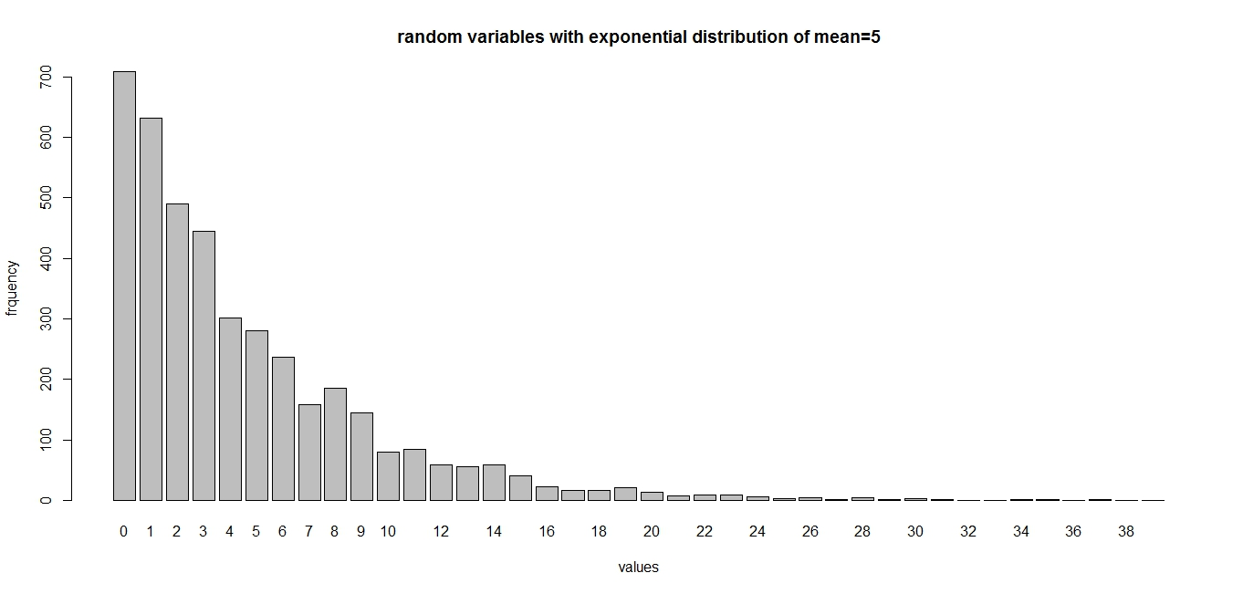

**The curve was smoothen and the following was obtained:**

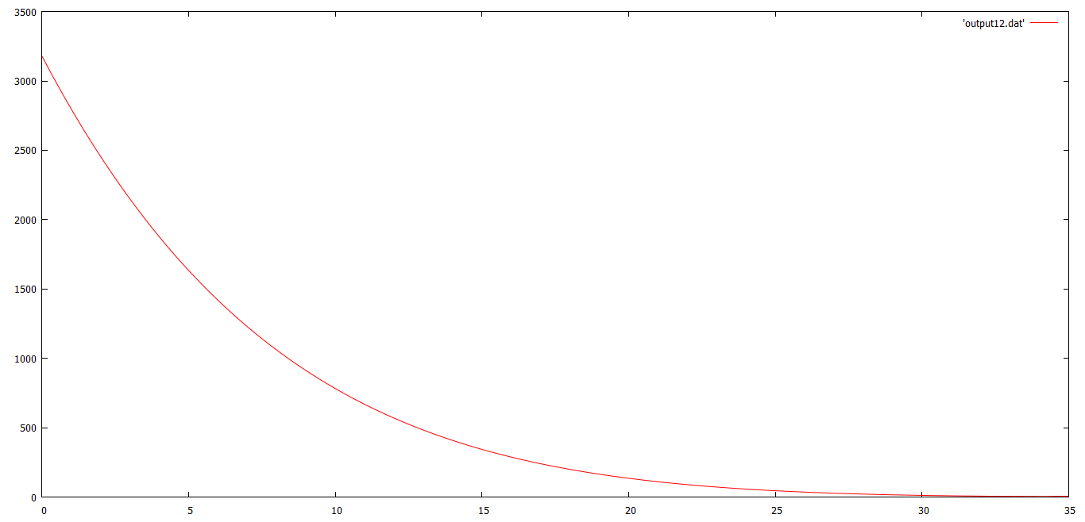

**Part II:**

This part focuses on the use of a sequence of samples. Here also we generate 5000 gamma samples from a sequence of 5 exponential samples;the following conversion is used:



**C++ implementation:**

#include<iostream>

#include<cstdio>

#include<cmath>

using namespace std;

int main()

{

int xo=5;

int initial=((1597*xo)+1)%244944;

int ini1=((1697*xo)+1)%244911;

int ini2=((1797*xo)+1)%244923;

int ini3=((1897*xo)+1)%244977;

int ini4=((1997*xo)+1)%244887;

double u1=(double)initial/244944;

double u2=(double)ini1/244911;

double u3=(double)ini2/244923;

double u4=(double)ini3/244977;

double u5=(double)ini4/244987;

int x,x1,x2,x3,x4;long count=0;

double z,z1,z2,z3,z4;

double sum=0;double ave;

double max=0,min;

x=((1597*initial)+1)%244944;

x1=((1697*ini1)+1)%244911;

x2=((1797*ini2)+1)%244923;

x3=((1897*ini3)+1)%244977;

x4=((1997*ini4)+1)%244887;

while(count!=5000)

{

u1=(double)x/244944;

x=((1597*x)+1)%244944;

u2=(double)x1/244911;

x1=((1697*x1)+1)%244911;

u3=(double)x2/244923;

x2=((1797*x2)+1)%244923;

u4=(double)x3/244977;

x3=((1897*x3)+1)%244977;

u5=(double)x4/244987;

x4=((1997*x4)+1)%244887;

z=-5*log(u5*u1*u2*u3*u4);

if(count==0)

min=z;

if(z<=min)

min=z;

if(z>=max)

max=z;

sum=sum+z;

cout<<z<<"\n";

count++;

}

ave=sum/5000;

cout<<"maximum="<<max<<"\n";

cout<<"minimum="<<min<<"\n";

cout<<"average="<<ave<<"\n";

return 0;

}

The program generates:

**Maximum=84.1948**

**Minimum=1.90412**

**Average=25.0022**

**Implementation using R:**

xo<-5

count<-1

f<-array(0,c(85))

initial<-((1597*xo+1))%% 244944

ini1<-((1697*xo)+1)%%244911

ini2<-((1797*xo)+1)%%244923

ini3<-((1897*xo)+1)%%244977

ini4<-((1997*xo)+1)%%244887

u<-initial/244944

u2=ini1/244911;

u3=ini2/244923;

u4=ini3/244977;

u5=ini4/244987;

z<-0

xaxis<-0:84

x<-initial

x1<-ini1

x2<-ini2

x3<-ini3

x4<-ini4

x<-((1597*x)+1)%% 244944

while (count<5000){

u<-x/244944

u2=x1/244911;

u3=x2/244923;

u4=x3/244977;

u5=x4/244987;

z<--5*log(u*u2*u3*u4*u5)

f[floor(z)]<-f[floor(z)]+1

print(paste(z))

x <- ((1597*x)+1)%% 244944

x1<-((1697*x1)+1)%%244911

x2<-((1797*x2)+1)%%244923

x3<-((1897*x3)+1)%%244977

x4<-((1997*x4)+1)%%244887

count<-count+1

}#using a while loop for the problem

print(f)

barplot(f,names.arg=xaxis,main="random variables with exponential distribution of mean=5",ylab="frquency",xlab="values")

**The bar plots:**

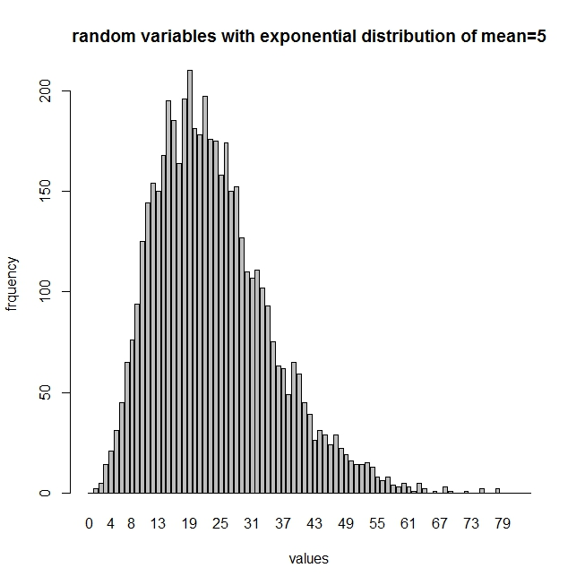

**The smooth curve:**

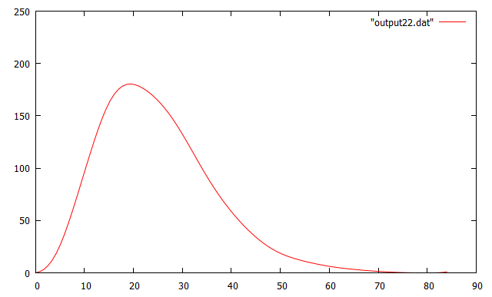

**Part III:**

This section uses the acceptance rejection method to generate from 20x(1-x)^3.

**R implementation:**

density <-function (n1) 20*n1*((1-n1)^3)

RejectionSampling <- function(n)

{

RN <- NULL

for(i in 1:n)

{

OK <- 0

while(OK<1)

{

T <- runif(1,min = 0, max = 1)

U <- runif(1,min = 0, max = 1)

if(2.5*U <= density(T))

{

OK <- 1

RN <- c(RN,T)

}

}

}

return(RN)

}

sample <-RejectionSampling(5000)

hist(sample, freq = TRUE, xlim = c(0,1), breaks = 100, main = "Rejection Sampling of f(x)=20x(x-1)^3");

**The Bar-plot obtained:**

